**DOCUMENTATION FOR MAPPING DOMAIN TO GCP.**

Step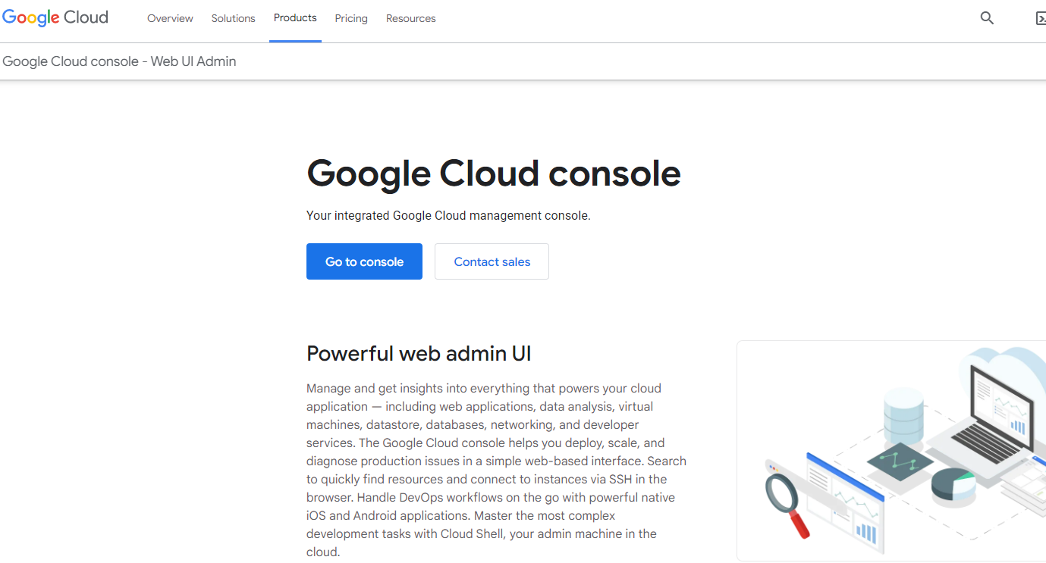 1: Open your browser and search for Google cloud platform and click on Go to Console.

Step 2 : Click on the Create a VM options.

Step 3: Click on the New VM Instance option on Left side and configure the name of the instance, Region, Zone, Machine Configuration of user needs.  
  
  
  
Step 4: If you want to change our instance operating system configuration click change on Boot Disk option and click Select.

Step 5: Make sure that you have to enable Firewall HTTP & HTTPS traffic and Click Create on below.

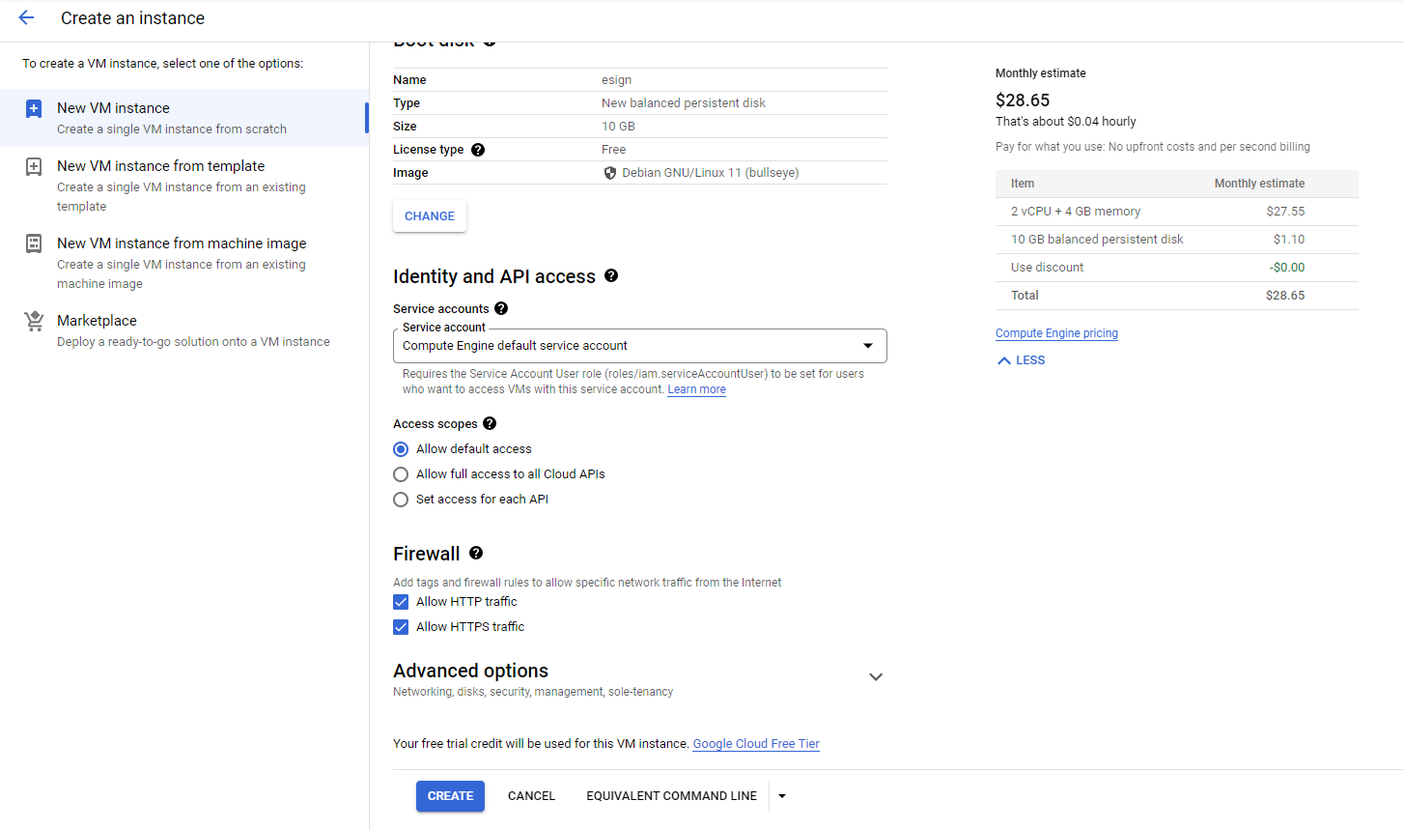

Step 6: Now you instance shown in VM instances tab and Copy your External IP.

Step 7: Now you want to create SSH key file so Open Putty gen and Click Generate option on Right side.

Step 8: It takes few minutes for Generating.

Step 9: Reconfigure the Key Comment it should be our instance username & copy the Public key.

Public Key

Step 10: Click the save private key Option on right side.

Step 11. Click Yes on Putty gen Warning.

Step 12: Browser your location to save your file name with extension of .ppk and Click Save.

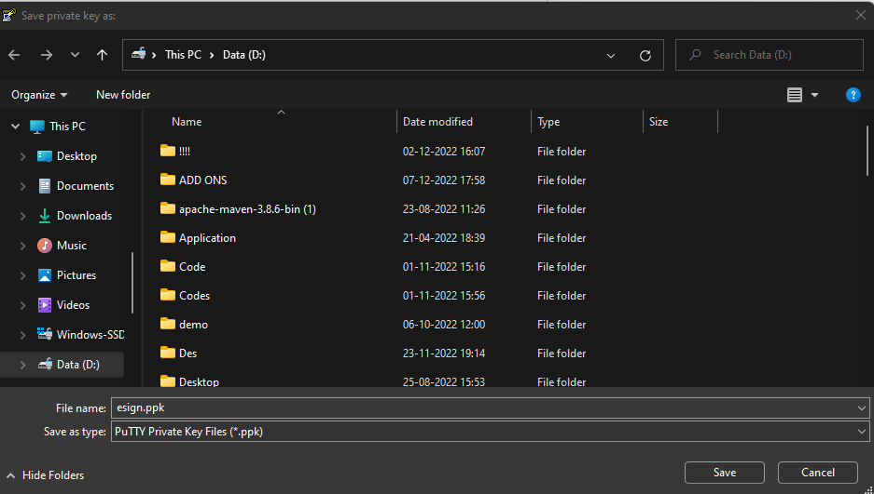

Step 13: Go to your GCP console and Click on VM instance on the Left Side and select your instance click on edit option on the top.

Step 14: Drop down to Security and access and click on the ADD ITEM option.

Step 15: Paste your public key as you copied from Step 9 and Click Save

Step 15: It automatically shown your username for corresponding public key as shown figure below.

Step 16: Back to GCP console and find networking on left side. Click on the VPC Network and Choose firewall.

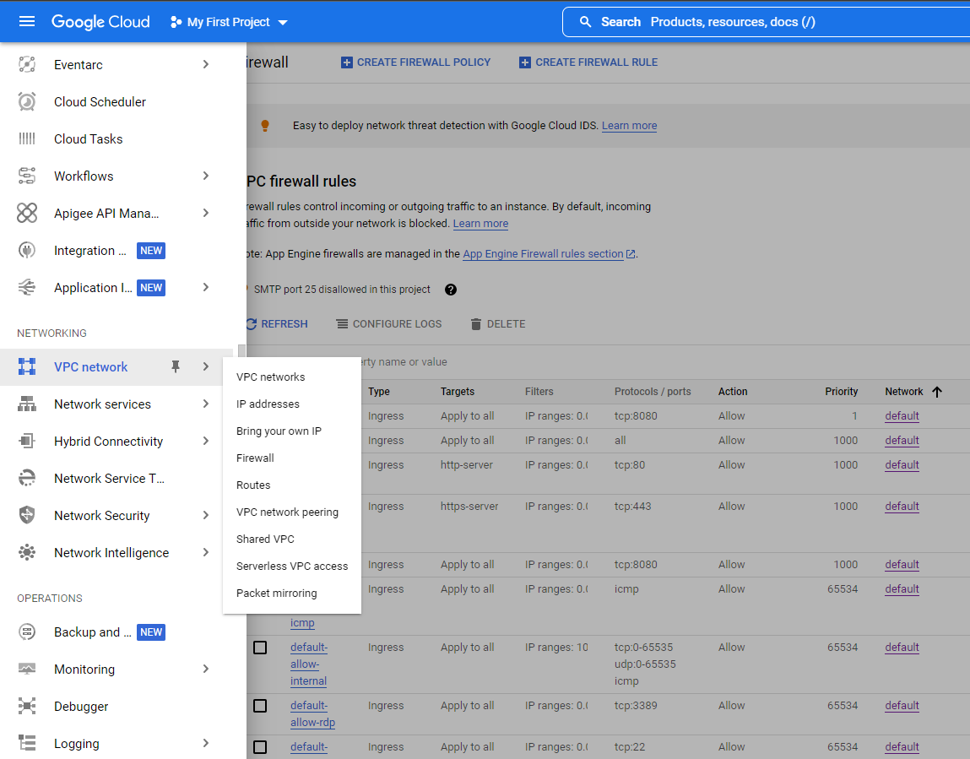

Step 17: To create a new firewall rule click on the create firewall rule

Step 18: Enter the name of the firewall rule with network, priority, direction of traffic and target.

Step 19: Select the Source filter, ranges with protocols and ports and Click create.

Step 20: You firewall rule shown in firewall.

Step 21: Copy the External IP of your instance.

Step 22: Open a putty and paste the instance external IP.

Step 23: Choose Connection -> SSH -> Auth and browser you ppk file as you generate in Step 12. Click open.

Step 24: New Dialog box is opened and click Accept.

Step 25: Enter the Username as you mention the key comment in Step 9.

Step 26: Now you can install all your prerequisite like java, maven, Git on your instance.

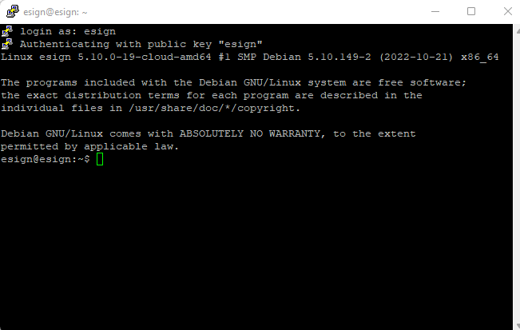

Step 27: Clone the repository that you have the java service (https://github.com/tempnjayaraj/javaService.git)

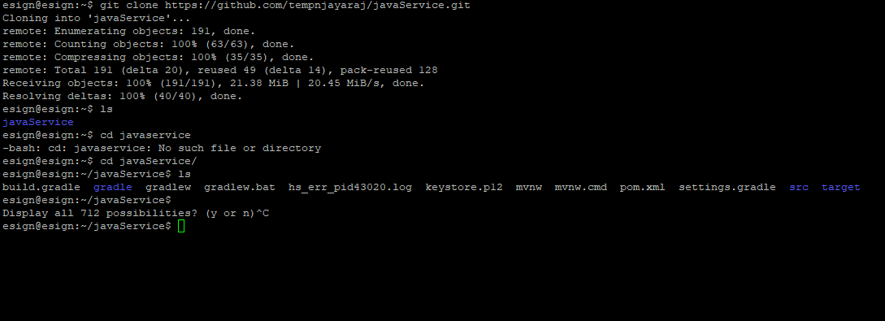

Step 28: To run your java application in Https. You need to generate keystore file in root of your directory with following commands (“keytool -genkey -keystore keystore.jks -alias ssl -keyalg RSA -sigalg SHA256withRSA -validity 365 -keysize 2048”) with following question that shown in the below picture

Step 29: Configure the port number with keystore file, password, type, alias.

Step 30: Run the command mvn spring-boot:run.

Step 31: Now you have to map your instance to DNS(For Ex: GoDaddy) open the GoDaddy console and click you profile select my product and Click on the DNS shown below.

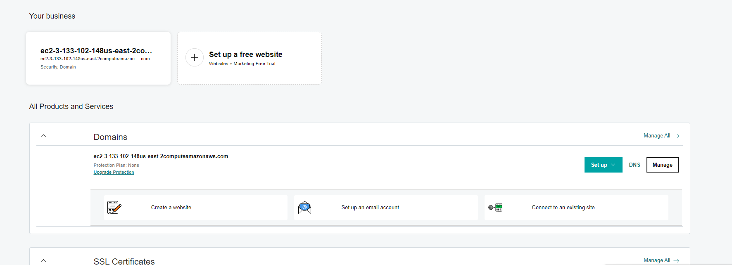

Step 32: Click edit icon at the type A

Step 33: Map your External IP of your Instance at value option and click Save.

Step 34: Now you can run the your domain with port as you mentioned in application.properties on your browser as it shown below. Click on Advanced

Step 35: Click on the procees to port(Unsafe)

Step 36: You got output.

